Golden Retriever puppies:
Sand Dancer’s Storm Surge CDX JH WC x Sand Dancer’s Windrush Whirlwind CD JH CGC
DOB- 9/19/2011, 5 males & 4 females
Since 1982 Sand Dancer Golden Retrievers has been dedicated to producing Goldens consistent with the breed standard in temperament and conformation while maintaining the highest standards on health/clearance issues and working ability. The sire/dam of each litter has eye, heart, elbow, and both PennHip and OFA hip clearances. Every puppy is temperament tested, socialized, and exposed to as many stimulating experiences as possible. Our puppies make loving family pets with the trainability, focus, and soundness to compete in any field. We currently have puppies available. The sire and dam are pictured below. If you are interested in more information, please contact Rhonda at sandancr@megalink.net or 207-743-8852.

Whirl
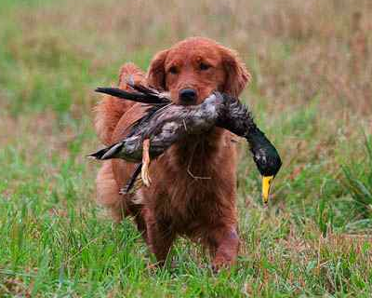
Rip
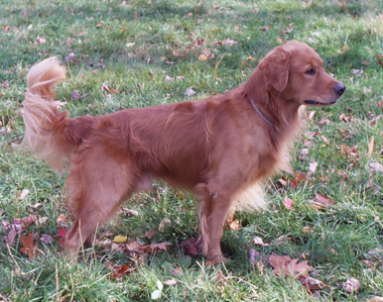
Sand Dancer Golden Retrievers

